**COP 1000C Intro Programming Concepts**

**Assignment 4 – Selection (if else)**

**Shipping Calculator:** Global Courier Services will ship your package based on how much it weighs and how far you are sending the package. Packages above 50 pounds will not be shipped. You need to write a program in C that calculates the shipping charge.

The shipping rates are based on per 500 miles shipped. They are not pro-rated, i.e., 600 miles is the same rate as 900 miles or 1000 miles.

Here are the shipping charges -

**Package Weight Rate per 500 miles shipped**

* Less than or equal to 10 pounds $2.00
* More than 10 pounds but less than or equal to 50 pounds $4.50

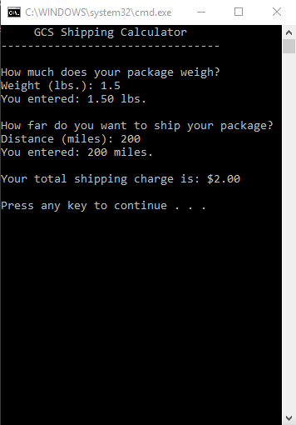

Here are some test cases.

**Test Case 1:**

**Input Data:**

Weight: 1.5 pounds

Miles: 200 miles (This is one 500 mile segment.)

**Expected results:**

Your shipping charge is $2.00

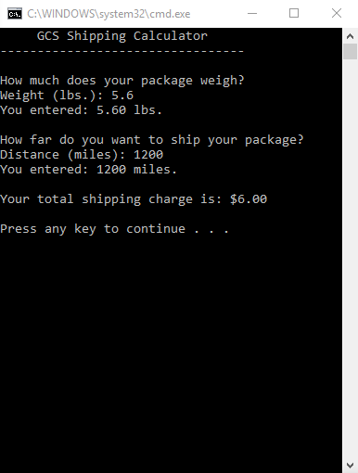**Test Case 2:**

**Input Data:**

Weight: 5.6 pounds

Miles: 1200 miles (This is three 500 mile segments.)

**Expected results:**

Your shipping charge is $6.00

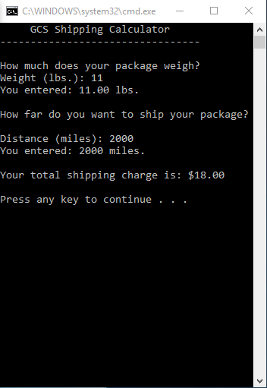**Test Case 3:**

**Input Data:**

Weight: 11.0 pounds

Miles: 2000 miles (This is four 500 mile segments.)

**Expected results:**

Your shipping charge is $18.00

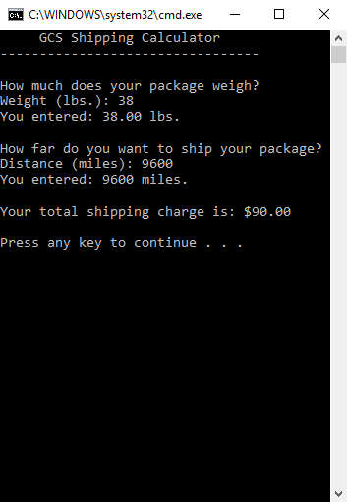

**Test Case 4:**

**Input Data:**

Weight: 38 pounds

Miles: 9600 miles (This is twenty 500 mile segments.)

**Expected results:**

Your shipping charge is $90.00

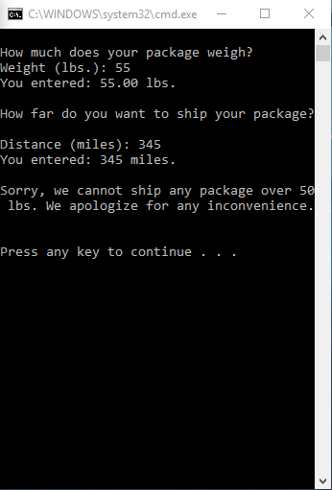

**Test Case 5:**

Weight: 55 pounds

Miles: 345 miles

**Expected results:**

Sorry, we only ship packages of 50 pounds or less.

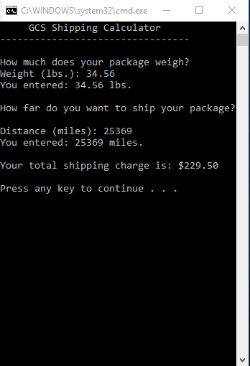Test Case 6:

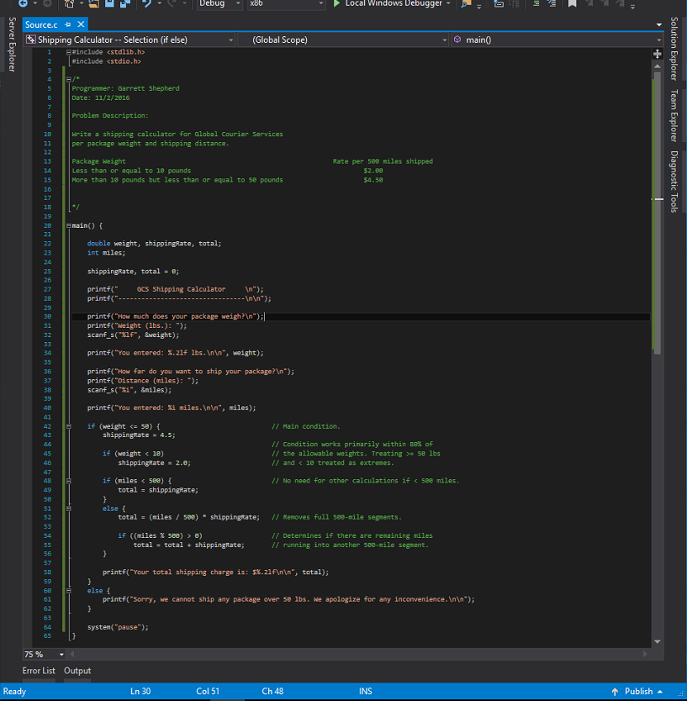

|  |  |  |
| --- | --- | --- |
| Input | Process | Output |
| weight | Ask the user for the weight of the package in pounds. | weight |
| miles | Ask the user for the shipping distance in miles. | miles |
|  | Set shipping rate based on weight in US dollars. |  |
|  | Calculate shipping total in US dollars per 500 miles multiplied by the shipping rate. |  |
|  | Output the total. | total |

You need to

1. Create an IPO. **(10 points)**
2. Create one more test case. **(4 points)**
3. Write and debug the code that solves the problem. **(55 points)**
4. Take screen shots of running the program six different times. Use five test cases given above and one more test case that you have created. (Total six test cases -**24 points**)
5. Include programmer name, date and brief problem description at the beginning of the code. **(2 points)**
6. Include meaningful comments wherever necessary. **(5 points)**

**Hints: This program does not need any loops. We are only up to video segment 7. It will calculate one shipping charge and stop.**

**Deliverables: Submit only one word file. No email submissions will be graded so remember to check your file before submitting for accuracy and completion.**

**Submit the Word document with solutions to all parts of the assignment via the Blackboard Assignment by the deadline.**

**Email me if you have any questions or if you get stuck.**